

**THE STATE UNIVERSITY OF ZANZIBAR**

**DEPARTMENT OF IT AND COMPUTER SCIENCE**

**COURSE TITLE: WEB TECHNOLOGY**

**COURSE CODE: INF 2215**

**INSTRUCTOR: MR MASOUD MMANGA**

**ASSIGNMENT TYPE:INDIVIDUAL ASSIGNMENT**

**STUDENT NAME: PATIMA KHAMIS MUHAMEDI**

**REGISTRATION NUMBER: BITAM/11/23/088/TZ**

**SUBMISSION DATE: 16/4/2025**

**QUESTION 1**

<!DOCTYPE html>

<html>

<head>

<meta charset="UTP-8">

<meta name="viewport" content="width=device-width, initial-scale=1.0">

<title>WEBSITE</title>

<link rel="stylesheet" href="style.css" />

</head>

<body>

<!-- Task 2:Headings, Paragraph, HR, BR-->

<h1>WElcome to My Website</h1>

<h2>This is the Heading2</h2>

<h3>This is the Heading3</h3>

<h4>This is the Heading4</h4>

<h5>This is the Heading5</h5>

<h6>This is the Heading6</h6>

<p>This paragraph gives you a brief introduction about my website.</p>

<hr>

<p>This is the second paragraph.<br>

And this line starts after a line break.</p>

<!-- Task 3: Lists-->

<h2>My 5 favorite books</h2>

<ol>

<li>Chemistry</li>

<li>Phyisics</li>

<li>Biology</li>

<li>Mathematics</li>

<li>History</li>

</ol>

<h2>My 5 Hobbies</h2>

<ul>

<li>Reading</li>

<li>Playing Game</li>

<li>Cooking</li>

<li>Running</li>

<li>Exercise</li>

</ul>

<!-- Task 4:Image with alt text-->

<h2>My Favourite Image</h2>

<img src="https://via.placeholder.com/200" alt="Placeholder image of nature scene" width="200">

<img src="https://via.placeholder.com/150" alt="Another Placeholder image" width="150">

<!-- Task 5: Links-->

<h2>useful Links</h2>

<P>

visit <a href="https://www.wikipedia.org" target="_blank">Wikipedia</a><br>

Watch videos on <a href="https://www.youtube.com" target="_blank">youtube</a><br>

Learn code at <a href="http://freecodecamp.org" target="_blank">freeCodeCamp</a>

</P>

<table style="width: 100;" border="1">

<tr>

<th>Monday</th>

<th>Tuesday</th>

<th>Wednesday</th>

<th>Thursday</th>

<th>Friday</th>

</tr>

<tr>

<td>Python</td>

<td>Java</td>

<td>Management</td>

<td>WebApplication</td>

<td>Principle of accounting</td>

</tr>

<tr>

<td>Cost</td>

<td>PC Maintanace</td>

<td>Programing</td>

<td>DEvelopment study</td>

<td>Enterpreneurship</td>

</tr>

<tr>

<td>Communication skills</td>

<td>PGIS </td>

<td>Data communication</td>

<td>English skill</td>

<td>Information system</td>

</tr>

<tr>

<td>Window</td>

<td>Linux</td>

<td>Math</td>

<td>Framework</td>

<td>Java Scripts</td>

</tr>

</table>

<img src ="image.jpg" alt="image" width="400">

img {

width: 100%;

max-width: 500px;

height: auto;

display: block;

margin: 0 auto;

}

</body>

</html>

**OUTPUT**

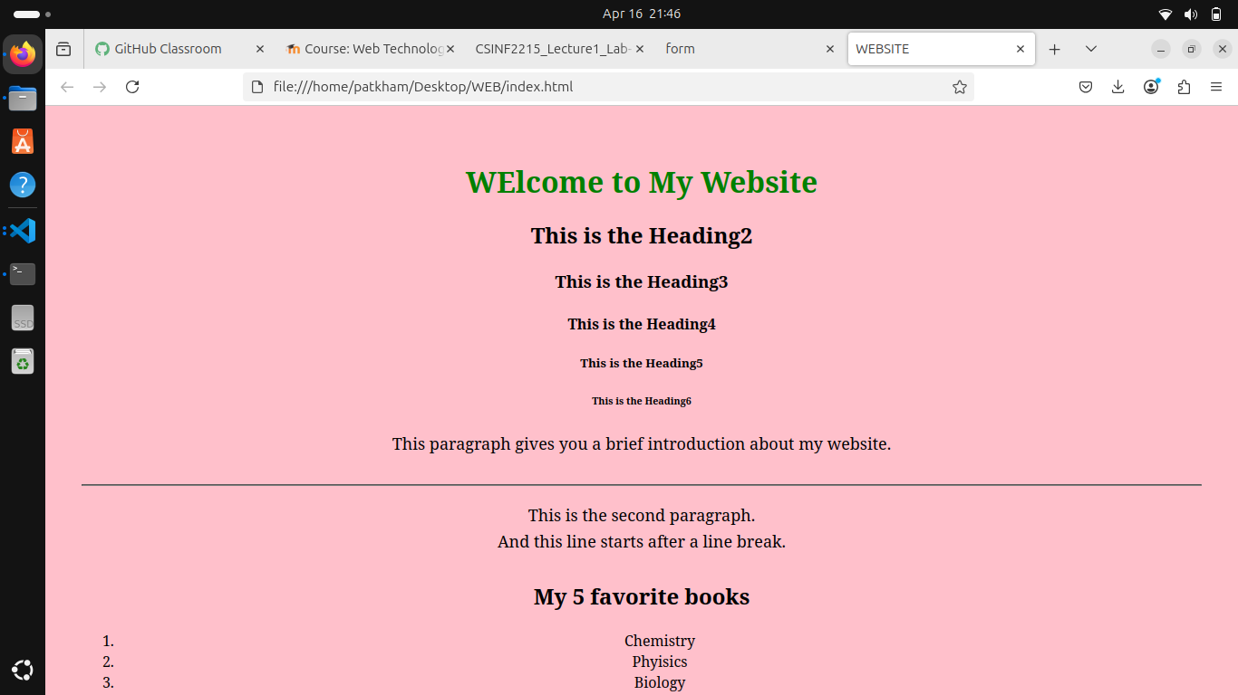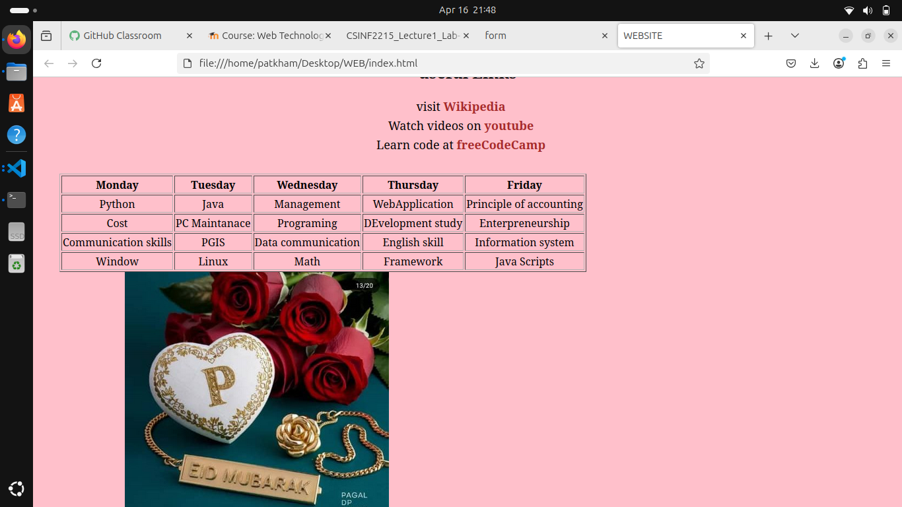

**QUESTION 3**

<!DOCTYPE html>

<html lang="en">

<head>

<meta charset="UTF-8">

<meta name="viewport" content="width=device-width, initial-scale=1.0">

<title>form</title>

<!-- <link href="https://cdn.jsdelivr.net/npm/bootstrap@5.0.2/dist.css/bootstrap.min.css" rel="stylesheet"> -->

</head>

<body>

<form action="" method="post">

<fieldset>

<label>Name</label>

<input type="text" name="name" class="form-control" placeholder="Enter your Name"><br><br>

<label>Email</label>

<input type="email" name="email" class="form-control" placeholder="Enter your Email"><br><br>

<label>Password</label>

<input type="password" name="password" class="form-control" placeholder="Enter your password"><br><br>

</fieldset><br><br>

<fieldset>

<lagend>Gender</lagend>

<input type="radio" id="male" name="gender" value="Male" required>

<label>Male</label>

<input type="radio" id="female" name="gender" value="Female" required>

<label>Female</label>

</fieldset><br><br>

<fieldset>

<label>Interest</label>

<input type="checkbox" name="interest" value="Sport">Sport<br>

<input type="checkbox" name="interest" value="Dancing">Dancing<br>

<input type="checkbox" name="interest" value="Exercise">Exercise<br><br>

<label for="country">Select your country:</label>

<select id="country" name="country">

<option value="">choose country do you preffer</option>

<option value="India">India</option>

<option value="Japan">Japan</option>

<option value="China">China</option>

</select>

</fieldset>

<label for="profile">choose Image</label><br><br>

<input type="file" id="Profile" name="Profile" accepts="image/*" required><br><br>

<input type="submit" value="upload">

</fieldset>

<br><br>

<button type="button" value="submit" name="login">Submit</button>

</form>

<!-- <script src="https://cdn.jsdelivr.net/npm/bootstrap@5.0.2/dist/js/bootstrap.bundle.min.js"></script> -->

</body>

</html>

**OUTPUT**

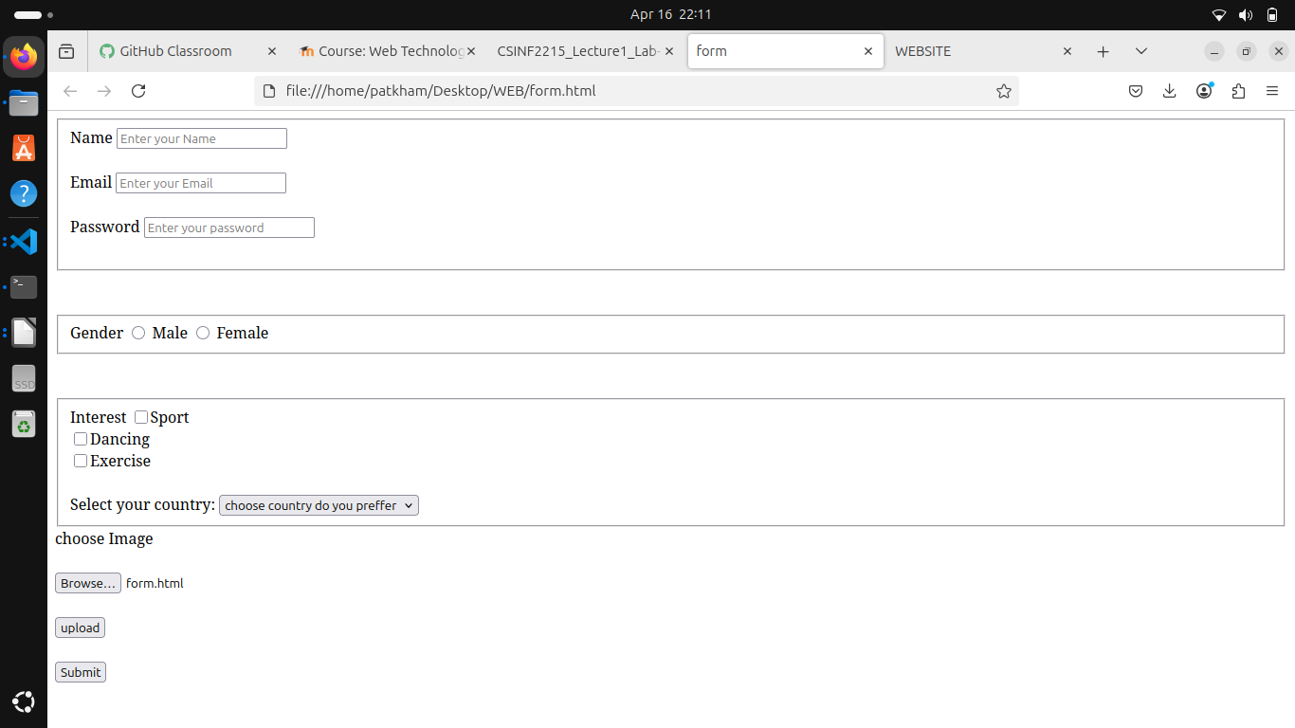

**QUESTION 4**

body {

background-color: pink;

font-family: Aerial;

color: purple;

margin: 0;

padding: 40px;

text-align: center;

}

h1 {

color: green;

margin-bottom: 20px;

}

p {

font-size: 18px;

line-height: 1.6;

margin-bottom: 30px;

}

a {

text-decoration: none;

color: brown;

font-weight: bold;

margin-right: 20px;

}

button {

padding: 10px 20px;

background-color: blue;

color: white;

border: none;

border-radius: 4px;

cursor: pointer;

}